***Virginia Junior Classical League***

*presents this*

Certificate of Excellence

*to*

William Greer

*of*

Ocean Lakes High School

*for*

*4th Place in Impromptu Art*

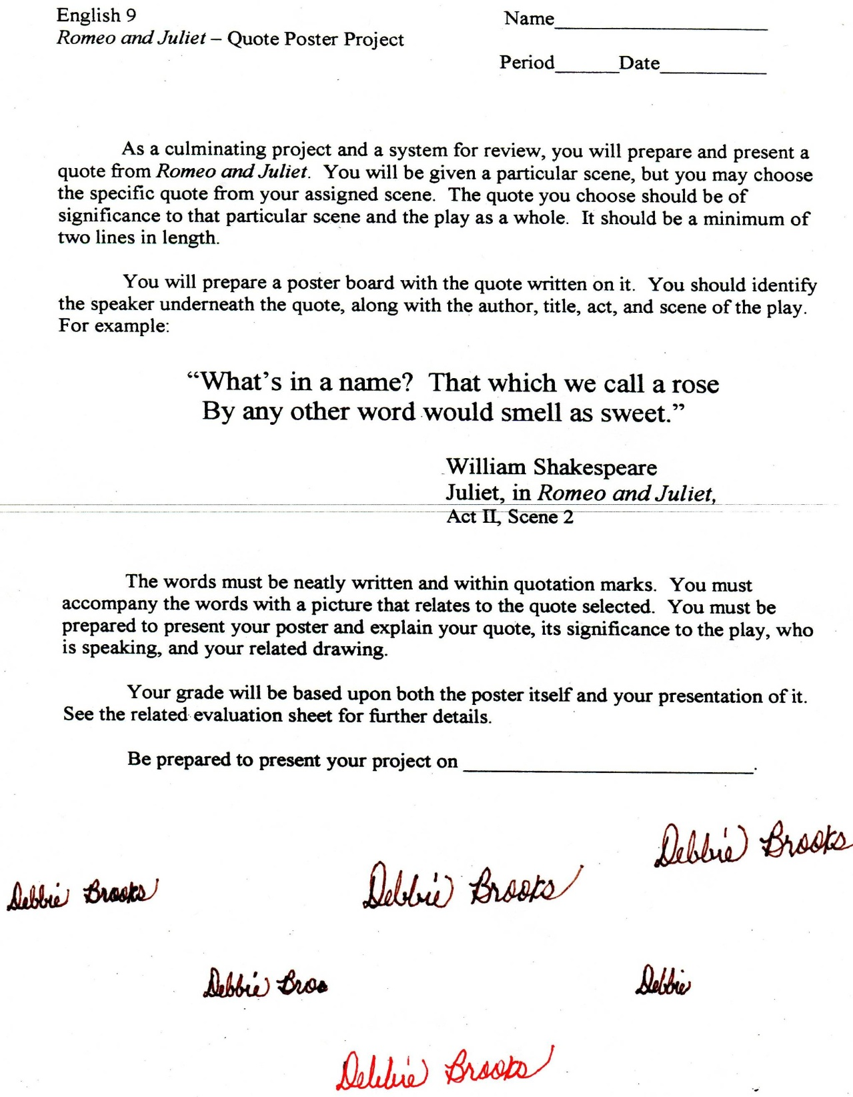

Microsoft Office Signature Line...

*a.d. viii Kal. Dec. MMDCCLXVII A.U.C. 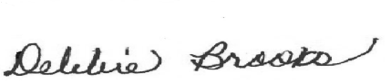*

***Virginia Junior Classical League***

*presents this*

Certificate of Excellence

*to*

William Greer

*of*

Ocean Lakes High School

*for*

*5th Place in Geography*

**

Microsoft Office Signature Line...

*a.d. viii Kal. Dec. MMDCCLXVII A.U.C. *

***Virginia Junior Classical League***

*presents this*

Certificate of Excellence

*to*

Katelynn Loos

*of*

Ocean Lakes High School

*for*

*5th Place in Impromptu Art*

**

Microsoft Office Signature Line...

*a.d. viii Kal. Dec. MMDCCLXVII A.U.C. *

***Virginia Junior Classical League***

*presents this*

Certificate of Excellence

*to*

Autumn Holt

*of*

Ocean Lakes High School

*for*

*8th Place in Life*

**

Microsoft Office Signature Line...

*a.d. viii Kal. Dec. MMDCCLXVII A.U.C. *

***Virginia Junior Classical League***

*presents this*

Certificate of Excellence

*to*

Rainielle Cua

*of*

Ocean Lakes High School

*for*

*9th Place in Life*

**

Microsoft Office Signature Line...

*a.d. viii Kal. Dec. MMDCCLXVII A.U.C. *

***Virginia Junior Classical League***

*presents this*

Certificate of Excellence

*to*

Rainielle Cua

*of*

Ocean Lakes High School

*for*

*9th Place in Pentathlon*

**

Microsoft Office Signature Line...

*a.d. viii Kal. Dec. MMDCCLXVII A.U.C. *

***Virginia Junior Classical League***

*presents this*

Certificate of Excellence

*to*

Luke Stanley

*of*

Ocean Lakes High School

*for*

*9th Place in Pentathlon*

**

Microsoft Office Signature Line...

*a.d. viii Kal. Dec. MMDCCLXVII A.U.C. *